

**Campus Care- Mind & Body**

Other free resource links for mindfulness and relaxation available on our Mental Health and Well-being resource sheet.



https://www.thinkuknow.co.uk/



Try to take regular breaks.

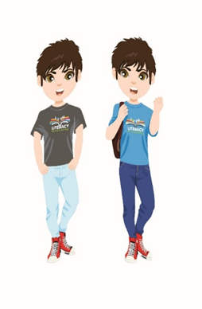

https://www.myworldofwork.co.uk/

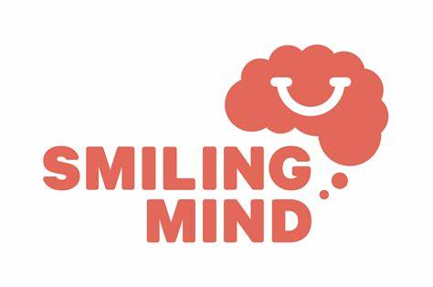

https://www.ceop.police.uk/safety-centre/

(S1-S6)

<https://nationalonlinesafety.com/guides>

(P5-S6)

https://www.youtube.com/user/CosmicKidsYoga







