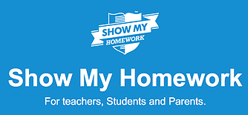

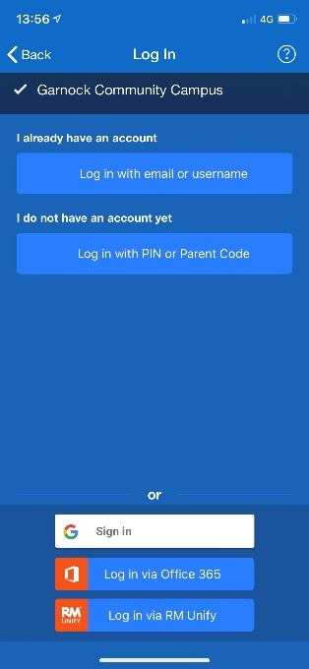
Show My Homework - Support for Pupils
On the app: When signing in to the Show My Homework app, search for ‘Garnock Community Campus’. Then, select ‘Log in via RM Unify’, and use your GLOW log in details (using the glow.sch.uk extension).
e.g. gw**************@glow.sch.uk

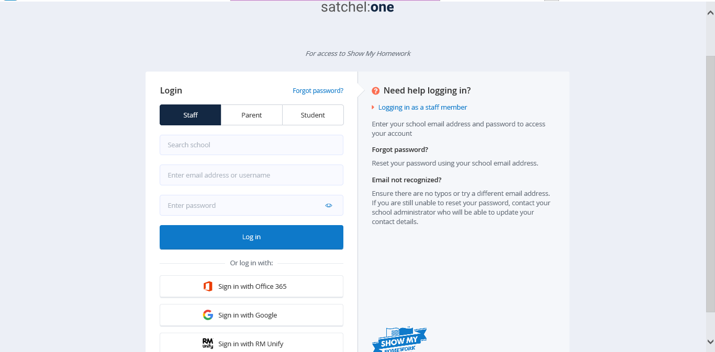
On the website: The GLOW tile is now active, and you should be signed in if you are already logged on to GLOW. If you are logging in through the website (www.satchelone.com/login), select ‘Sign in with RM Unify’.

Use your GLOW log in details (using the glow.sch.uk extension).
e.g. gw*************@glow.sch.uk

