Apps and Websites to Support Mental Health and Well-Being
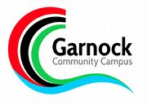
NHS Ayrshire & Arran’s Public Mental Health & Wellbeing Network has prepared guidance on some examples of Apps and websites to support mental health and wellbeing; we do not endorse or recommend particular resources, and encourage you to carefully explore resources before you use them. All the Apps are free to download but some do have in app purchases so we urge you to be cautious when exploring some of the features. (October 2019)
Teenagers and Adolescents
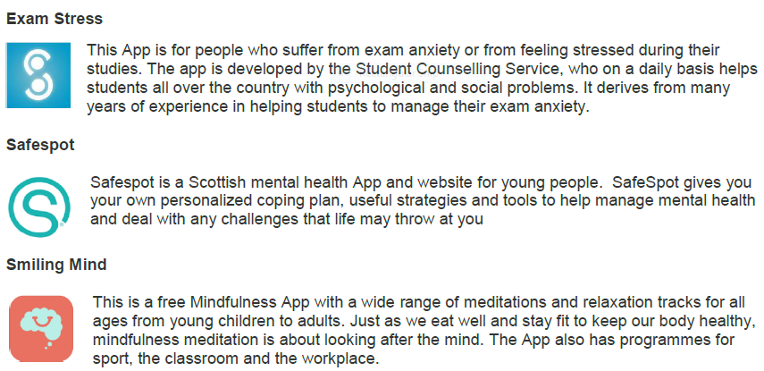
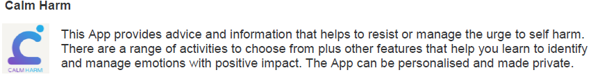
Adults, teenagers and adolescents
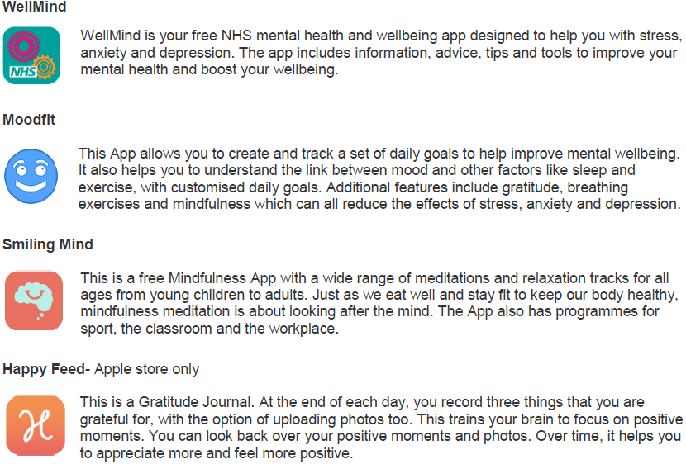
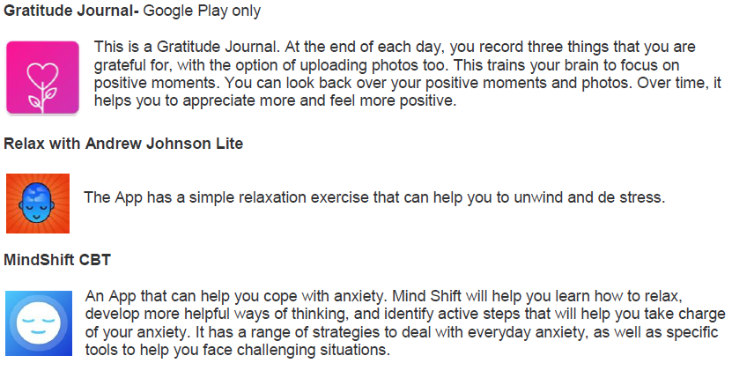
NHS Inform
NHS inform is Scotland's national health information service helping the people in Scotland to make informed decisions about their own health and the health of the people they care for. There is information on a range of mental health and wellbeing topics.
Available at https://www.nhsinform.scot

NHS Ayrshire & Arran: Better Health- Mental Health and Wellbeing
This website provides a range of information on how to look after our mental health and wellbeing. There are also links to self help tools and resources to help cope with common problems including low mood, anxiety and stress.
Available at https://www.nhsaaa.net/better-health/topics/mental-health-and-wellbeing/
Moodzone
Practical information, interactive tools and videos from the NHS to help you look after your mental health and avoid common problems like depression, anxiety and stress.
Available at https://www.nhs.uk/Conditions/stress-anxiety-depression
The Mental Health Foundation
The Mental Health Foundation is a UK charity promoting good mental health for all. This website has a range of information, resources and self help tools.
Available at https://www.mentalhealth.org.uk/Scotland
Aye Mind
Aims to improve the mental health and wellbeing of young people by making better use of the internet, social media and mobile technologies. They are working with young people aged 13 to 21 to create and share a wide range of resources. They are also making a digital toolkit for all who work with young people too, to boost their ability to promote youth wellbeing.
Available at: http://ayemind.com/
Choose Life
Prevention of suicide, and provision of information and support for individuals who are feeling suicidal or worried about someone else.
Available at: http://www.chooselife.net/
NHS 24 Contact free on: 111 Visit Website: https://www.nhs24.scot/

Breathing Space Contact free on: 0800 83 85 87 Visit Website: https://breathingspace.scot

Child line Contact free on: 0800 1111 Visit Website: https://childline.org.uk/
Free counselling https://www.childline.org.uk/get-support/1-2-1-counsellor-chat/

Samaritans Contact free on: 116 123 Visit Website: http://www.samaritans.org/

YoungMind crisis number – text YM to 85258 Visit Website: https://youngminds.org.uk/

Kooth Online, confidential support (incl. 1-to-1 counselling) Visit Website: https://www.kooth.com/

If you have followed the advice and tried the self help tools on the above Apps and websites and feel that you need additional support we would encourage you to talk to a trusted individual for example a friend, family member or GP.

