Garnock Community Campus
Beith Road
Glengarnock
KA14 3BF

Phone: 01505 682685
Fax: 01505 684876
Email: garnock@ea.n-ayrshire.sch.uk
www.garnockcommunitycampus.co.uk
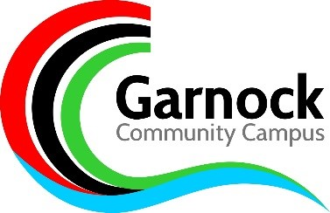

Dear Parent / Carer

As you will be aware the Scottish Government announced that all schools will close from Monday 23rd March - with the exception of critical provision for 3 distinct groups of pupils:
- Vulnerable children as identified by the school and authority
- Children of Key Workers who cannot find alternative care for their child
- S4-S6 who still need to complete outstanding coursework.

It is envisaged that the vast majority of pupils ( S1 – S6 ) will be at home, with appropriate work being set via Show My Homework, email, GLOW and Google Classrooms. Year Heads and Pastoral Staff will be offering remote pastoral support via email or phone and will continue to liaise with all appropriate external agencies.
North Ayrshire Council will be contacting parents directly regarding children of key workers and they will communicate the provision to parents on a regular basis.
A short term provision is in place for Senior Phase Students (S4 – S6) that are required to complete SQA coursework and outstanding work associated with SQA.
We are currently working to provide a service that will allow students to complete all pieces of SQA work as soon as possible.
Students will be contacted by subjects via email to offer them targeted individual opportunities for them to be in school and undertake any outstanding coursework. Text messages will also be issued to parents detailing when students are required to attend school.
Only students contacted by Faculty Leaders / DHT should be in school. It is expected that this provision will start from Monday 23rd March.
During this time school transport will operate as normal. There is no expectation that students should wear school uniform during this time. A morning break service and lunch will be available every day until the Easter holidays.
As you will understand, this is a fast moving situation and more information will be issued as we receive details. Further information is available for all pupils and parents via our school website (www.garnockcommunitycampus.co.uk ) as the school office will not be open.
Yours sincerely
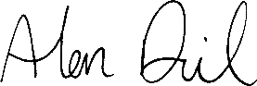
Alan Dick

